Python programs of exception handling

1.

def div(a,b):

assert(b!=0),"Division by zero is not defined"

return a/b

try:

print(div(20,3))

print(div(100,20))

print(div(50,0))

except AssertionError as ob:

print(ob)

print("Okay")

**Output**

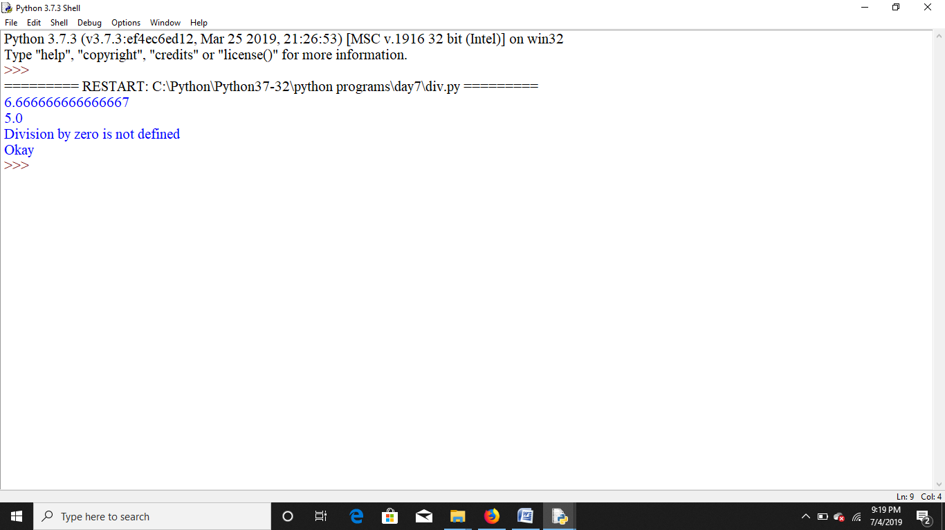

2.

def KelvinToFahrenheit(Temperature):

assert (Temperature>=0),"Colder than absolute zero!"

res=((Temperature-273)*1.8)+32

return res

try:

print(KelvinToFahrenheit(273))

print(KelvinToFahrenheit(505.78))

print(KelvinToFahrenheit(-5))

except AssertionError as ob:

print(ob)

print("Thank you")

**Output**

